# SOFTWARE TESTING

Project – Task 6  
(Study and identify automation project failure root cause)

**Group**: ST-G10

**Members**:

Sheraz Ahmad (L13-4049)

Asad Khalil (L17-4275)

Jawad (L17-4376)

**Study and Identify Automation Project Failure Root Cause**

Following are the failures

# 1: People start using test automation where manual testing is required

We always want to automate something that is stable, that is less prone to change, that has to be repeated multiple number of times, or that will help save valuable testing effort. By automating mundane and repetitive tasks, testers can spend their valuable testing effort on performing [exploratory testing](https://blog.testim.io/exploratory-testing/).

It is important to understand what to automate and what not to automate.

But unfortunately, people start using test automation where manual testing is required. As a result, the automation test resulting in a failure of the test. People start using test automation on WebPages which have different resolution on different devices and to see the elements in the Web Pages we should have to use manual test by a human by which he can do well and by this way we can test our web pages more correctly.

# 2: Some applications are not easily testable

Some of the developers built the applications that are not be tested under test automation. We should have to ensure that the system should be testable from any angle from unit level, system level and from integration level.

When you neglect this aspect, we end up having an application that is almost impossible to test from any level. Then we think automation is not working for the team, when the real problem is that some of the developers are building applications that are too complex and not testable.

Ensure you discuss the testability of a story, a feature, and requirements during backlog grooming and the sprint planning meeting, before the development effort starts on a feature. This will help to prevent problems later in the development lifecycle

# 3. The team doesn’t have good processes to handle automation tasks

This is one of the most common problems with test automation: There is no proper process in place to handle automation tasks. Each team member has their own interpretation of the process, leading to chaos and failure of the automation project.

The process of automation should be streamlined and clearly defined right from the start to the finish of the lifecycle of a story. So that no problem could be arising between the processes of test automation. There should be no ambiguity what to do and when to do and how to do. These things should be clarified at the start of the working. As a **result,** the test automation **fails,** and everybody start blaming others.

# 4: Cypress will not stop test run if errors in before hook

**Actual behavior:**

If an error is raised in the before hook for tests, Cypress will not stop the test run and seems to continue indefinitely.

**Desired behavior:**

Tests should fail with a descriptive error message.

**How to reproduce:**

Run the below code

***Test code:***

describe('Demo throw in before hook', () => {

before(() => {

cy.exec('echo "test test"').then(() => {

throw new Error('something broke');

});

});

it('visits url', () => {

cy.get('/');

});

// NB: for some reason if I comment out the below test

// Cypress UI will fail the test correctly.

it('gets element', () => {

cy.get('.someelem');

});

});

**Additional Info (images, stack traces, etc)**

Below is a screenshot that shows that although the error is thrown, the spinner still continues to... spin

[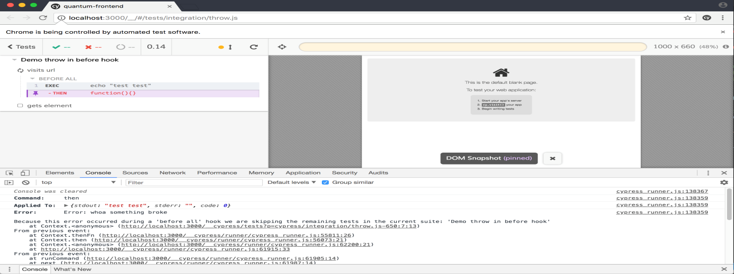](https://user-images.githubusercontent.com/342638/36369836-5b0472d6-158f-11e8-910d-479ac62eb17e.png)

**5: Using Automated Testing to Overcome Delivery Challenges**

If you are working with the agile methodology and had deployments every two weeks. After every deployment, testers faced time constraints, as they had to test the newly deployed features as well as perform regression testing. So due to the pressure of the delivery challenges your test automation become fail.

**6:  Unable to describe a specific business need/objective**

These tests (Automation Projects) fail when they are technical exercises that are not tied to specific business needs. If the Return on Investment is not clearly understood, you are unlikely to get the funding to do automation correctly. Instead you will find your efforts rushed to just implement ‘Automation’ and move on. Months later, everyone is confused why automation hasn’t been completed, why it doesn’t do x, y, z and why all the things they assumed would be included were never planned.

Nothing is worse than a team of automation engineers thinking they are making great progress, just to have the business decide to pull apart the team due to a lack of understanding the value. If you are running automation directly tied to an understood business need, then the business leaders will be invested. You will find support because your metric will clearly show the value being produced.

So, concluded that if you are didn’t know about the goals and objectives of the project you cant test it by doing test automation. So, you first must know the need and objectives of the business and then start doing test automation.